**SEED QUALITY TESTING USING CNN AND GAN**

**A COMMUNITY SERVICE PROJECT REPORT**

***Submitted by***

**K.PARAMESH(9920004808)**

**U.ROHITH(9920004138)**

**U.ANIL KUMAR(9920004263)**

**P.LAKSHMI CHAITANYA(9920004261)**

***In partial fulfillment for the award of the degree***

***of***

# BACHELOR OF TECHNOLOGY

## IN

Computer Science and Engineering



**SCHOOL OF COMPUTING DEPARTMENT OF COMPUTER SCIENCE AND ENGINEERING**

**KALASALINGAM ACADEMY OF RESEARCH AND EDUCATION**

## KRISHNANKOIL 626 126

Academic Year 2022-2023

**DECLARATION**

We affirm that the project work titled **“SEED QUALITY TESTING USING CNN AND GAN”** being submitted in partial fulfillment for the award of thedegree of **Bachelor of Technology in Computer Science and Engineering** is the original work carried out by us. It has not formed the part of any other project work submitted for award of any degree or diploma, either in this or any other University.

# K.PARAMESH(9920004808)

# U.ROHITH(9920004138)

# U.ANIL KUMAR(9920004263)

# P.LAKSHMI CHAITANYA(9920004261)

# 

#### BONAFIDE CERTIFICATE

Certified that this project report **“SEED QUALITY TESTING USING CNN AND GAN”** is the bonafide work of “**k.Paramesh,U.Rohith,U.Anil Kumar,P.Lakshmi Chaitanya”** who carried out the project work under my supervision.

**SUPERVISOR HEAD OF THE DEPARTMENT**

Mr.K.Vignesh Dr. P.DEEPALAKSHMI

Assistant Professor Professor & Head

Computer Science and Engineering Computer Science and Engineering

**Kalasalingam Academy of Research and Kalasalingam Academy of Research and and Education and Education**

Krishnankoil 626126 Krishnankoil 626126

Submitted for the Project Viva-voce examination held on 27/4/2023

**Internal Examiner External Examiner**

**ACKNOWLEDGEMENT**

First and foremost, I wish to thank the **Almighty God** for his grace and benediction to complete this Project work successfully. I would like to convey my special thanks from the bottom of my heart to my dear **Parents** and affectionate **Family members** for their honest support for the completion of this Project work.

I express deep sense of gratitude to “Kalvivallal” Thiru. **T. Kalasalingam** B.com., Founder Chairman, “Ilayavallal” **Dr. K. Sridharan,** Ph.D., Chancellor, **Dr. S. Shasi Anand**, Ph.D., Vice President(Academic), **Mr. S. Arjun Kalasalingam** M.S., Vice President(Administration) , **Dr. S. Narayanan**, Vice-Chancellor, **Dr. V. Vasudevan,** Ph.D., Registrar , **Dr. P. Deepalakshmi,** Ph.D., Dean (School of Computing) and Head, Department of CSE, Kalasalingam Academy of Research and Education for granting the permission and providing necessary facilities to carry out Project work.

I would like to express my special appreciation and profound thanks to my enthusiastic Project Supervisor **Mr.K.Vignesh** , Assistant Professor/CSEof Kalasalingam Academy of Research and Education [KARE] for his inspiring guidance, constant encouragement with my work during all stages. I am extremely glad that I had a chance to do my Project under my Guide, who truly practices and appreciates deep thinking. I will be forever indebted to my Guide for all the time he has spent with me in discussions. And during the most difficult times when writing this report, he gave me the moral support and the freedom I needed to move on.

Besides my Project guide, I would like to thank the rest of Class committee members and all faculty members and Non-Teaching staff for their insightful comments and encouragement. Finally, but by no means least, thanks go to all my school and college teachers, well wishers, friends for almost unbelievable support.



**School of Computing**

**Department of Computer Science and Engineering**

**Project Summary**

|  |  |  |
| --- | --- | --- |
| Project Title | Seed Quality Testing using CNN and GAN | |
| Project Team Members | 1. K.Paramesh(9920004808) 2. U.Rohith(9920004138) 3. U.Anil Kumar(9920004263) 4. P.Lakshmi Chaitanya(9920004261) | |
| Guide Name/Designation | Mr.K.Vignesh, Assistant Professor, Department of Computer Science and Engineering | |
| Program Concentration Area | Seed Quality Prediction | |
| Technical Requirements | **pycharm and html css and javascript** is used by the developer to complete the project. | |
| Engineering standards and realistic constraints in these areas: (Refer Appendix in page 4 of this doc.) | | |
| **Area** | **Codes & Standards / Realistic Constraints** | **Tick ✓** |
| Economic |  |  |
| Environmental | Seed Quality Testing has direct impact on the environment as it helps to promote sustainable agriculture practices and the conservation of natural resources. | **✓** |
| Social |  |  |
| Ethical |  |  |
| Health and Safety |  |  |
| Manufacturability |  |  |
| Sustainability |  |  |

**Realistic Constraints:**

**Environmental:**

Seed quality testing is an essential process for ensuring that high-quality and genetically diverse seeds are used for agricultural purposes. This has a direct impact on the environment as it helps to promote sustainable agriculture practices and the conservation of natural resources.

Here are a few ways in which seed quality testing is useful for the environment:

Improved crop productivity: Seed quality testing helps to identify and eliminate low-quality or diseased seeds, ensuring that only the best-quality seeds are used for planting. This results in improved crop productivity, which can help to reduce the need for expanding agricultural land, thus protecting natural ecosystems from destruction.

Conservation of biodiversity: Seed quality testing ensures that a wide range of genetic diversity is maintained in crop plants. This is essential for the conservation of biodiversity, as it helps to preserve the genetic resources of different crop varieties and their wild relatives. This can help to protect endangered species, maintain ecological balance, and promote long-term sustainability.

**Engineering standards:**

Seed quality testing is a critical step in ensuring that high-quality seeds are used for agricultural purposes, which is essential for sustainable agriculture practices and environmental conservation. The use of convolutional neural networks (CNN) and generative adversarial networks (GAN) can significantly enhance the accuracy and efficiency of seed quality testing. Engineering standards for seed quality testing using CNN and GAN may involve standardized data collection, pre-processing, and augmentation techniques, development of CNN and GAN models, and implementation of a testing protocol. By following these standards, we can develop an accurate, efficient, and reliable seed quality testing process that helps ensure the quality and genetic diversity of seeds, promote sustainable agriculture practices, and protect the environment.

**ABSTRACT**

Seed quality testing is a critical process in agriculture to ensure the production of high-quality crops.Traditional seed testing methods involve time-consuming and labor-intensive processes that are prone to human errors.This paper presents an approach to find The quality and properties of 6 different seeds such as cucumber,pea,soyabean ,tomato,watermelon and maize.This Methodology classifies the seed as excellent or good or average or bad or worst quality and also find the properties of the seeds based on the give input seed image.This methodology uses the deep learning algorithms such as Convolutional Neural Networks (CNN) and Generative Adversarial Networks (GAN) to test the quality of the seed based on the give input seed image.The CNN model achieved high accuracy rates in seed quality classification, outperforming traditional seed testing methods. Furthermore GAN model with the CNN model to generate synthetic seed images for training data augmentation.The GAN model learned to generate realistic synthetic seed images, thereby increasing the size and diversity of the training dataset.

**CONTENTS**

|  |  |  |
| --- | --- | --- |
| **ABSTRACT** | | |
| **LIST OF FIGURES** | | |
| **LIST OF ABBERIVATION** | | |
| **CHAPTER I** | **INTRODUCTION……………………………………….………....12** |
| 1.1 | Overview |
| 1.2. | Types of Seeds |
| 1.3. | maize |
| 1.4. | Tomato |
| 1.5. | Watermelon |
| 1.6. | cucumber |
| 1.7. | pea |
| 1.8. | soyabean |
| **CHAPTER II** | **LITERATURE REVIEW ………………………………...………17** |

**CHAPTER III PROBLEM DEFINITION……………………………………………………18**

**CHAPTER IV REQUIREMENTS ……………………………………………………………19**

4.1 Requirement Description

4.2 Hardware requirements

4.3 Software requirements

**CHAPTER V SYSTEM DESIGN…………………………………………………………21**

5.1 Data collection

5.2 Data preprocessing

5.3 Model development

5.4 Model training

5.5 Model evaluation

**CHAPTER VI DESIGN ALTERNATIVES…………………....................................22**

6.1 Transfer learning with CNNs and GANs

6.2 Autoencoders

**CHAPTER VII PROPOSED APPROACH ……………………....................................23**

7.1 Proposed Work

7.2 About Required Algorithms

7.3 Work Flow of Algorithms

**CHAPTER VIII MODULE DESCRIPTION………………………………………….27**

8.1. Data preprocessing

8.2. Deep learning

8.3. User interface

8.4. Deployment

**CHAPTER IX IMPLEMENTATION AND RESULT..………………………..........28**

9.1 Coding

9.2 Experiment Result

9.3 Output screenshot

**CHAPTER X CONCLUSION AND FUTURE ENHANCEMENT………………...44**

10.1 Conclusion

**CHAPTER XI REFERENCES……………………………………………………….....45**

**LIST OF FIGURES**

|  |  |
| --- | --- |
| **FIGURES** | **DETAILS** |
| Figure 1 | Figure 1:maize |
| Figure 2 | Figure 2:tomato |
| Figure 3 | Figure 3: watermelon |
| Figure 4 | Figure 4: cucumber |
| Figure 5 | Figure 5: pea |
| Figure 6 | Figure 6: soyabean |
| Figure 7 | Figure 7: Convolutional Neural Networks CNN |
| Figure 8 | Figure 8: Generative Adversarial Network GAN |
| Figure 9 | Figure 9: Flow chart of proposed model |
| Figure 10 | Figure 10: User Interface |
| Figure 11 | Figure 11: properties of maize seed |
| Figure 12 | Figure 12: properties of tomato seed |
| Figure 13 | Figure 13: properties of cucumber seed |
| Figure 14 | Figure 14: properties of pea seed |
| Figure 15 | Figure 15: properties of soyabean seed |
| Figure 16 | Figure 16: properties of watermelon seed |

**LIST OF ABBREVIATIONS**

|  |  |
| --- | --- |
| CNN | Convolutional Neural Network |
| GAN | Generative Adversarial Network |
| AI | Artificial Intelligence |
| ML | Machine Learning |
| RGB | Red, Green, Blue (color model) |
| RELU | Rectified Linear Unit |
| FFNN | Feed Forwared Neural Network |

**CHAPTER I:**  **INTRODUCTION**

### OVERVIEW

### In the agricultural industry, seed quality testing is a critical process to ensure high crop yields and quality. However, manual inspection and evaluation of seeds are time-consuming and prone to errors. Moreover, in the commercial seed cultivation sector, filtering out damaged seeds and foreign elements in voluminous amounts of seeds is not feasible, and manual filtering can lead to poor quality seeds and waste of fine quality seeds. To address these issues, there is a need for an automated approach to seed quality testing that is efficient, accurate, and scalable.

### Deep Neural Networks (DNNs) and Convolutional Neural Networks (CNNs) are powerful tools that can be used for image classification and object recognition tasks. However, creating large-scale, high-quality datasets for training these models can be challenging. There may be an imbalance of seeds in a sample with a specific defect, resulting in small datasets skewed to non-defective classes.

### To address these challenges, Generative Adversarial Networks (GANs) can be used to generate synthetic images that closely resemble real ones and augment the training data, improving the accuracy of the CNN model. By combining CNN and GAN, seed quality testing can be automated, reducing time and costs, while improving accuracy and consistency.

### In summary, automating seed quality testing is crucial in the agricultural industry. CNN and GAN can be used to analyze seed images and predict their quality, significantly reducing the time and cost involved in seed quality testing, while also improving the accuracy and consistency of the results.

### TYPES OF SEEDS

6 types of seeds are being used in this project they are

1. Maize
2. Tomato
3. Watemelon
4. Cucumber
5. Pea
6. soyabean

### MAIZE

Maize, also known as corn, is a cereal crop that belongs to the grass family, Poaceae. It is one of the most widely cultivated crops in the world and is a staple food in many countries, particularly in Africa, Latin America, and parts of Asia. Maize plants can grow up to 3 meters tall, with long green leaves and large ears that contain the kernels. Maize kernels vary in color, ranging from white, yellow, red, blue, and purple, depending on the variety. The kernels are rich in carbohydrates, proteins, and fiber, making maize an important source of nutrition for both humans and livestock.

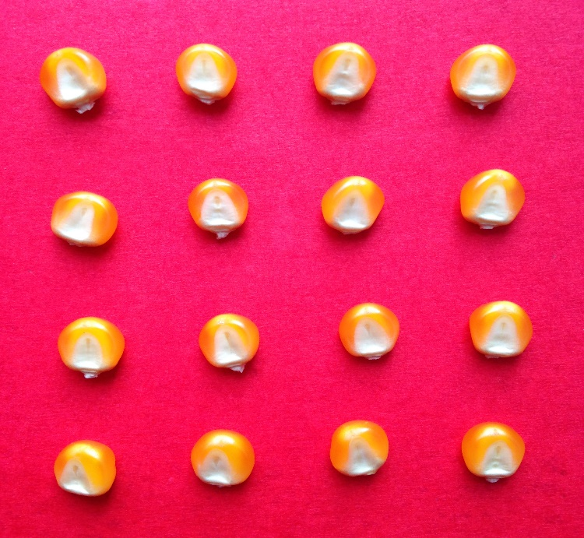

**Figure 1:maize**

### TOMATO

Tomato seed is a vital part of tomato plant propagation and cultivation. Tomato seeds are small, flat, and oval-shaped, measuring approximately 3-4 mm in diameter. The seeds are usually yellowish-white, but they can vary in color depending on the variety of tomato. The seed coat is hard and protects the embryo inside, which contains all the genetic information necessary for the plant to grow and produce fruit.

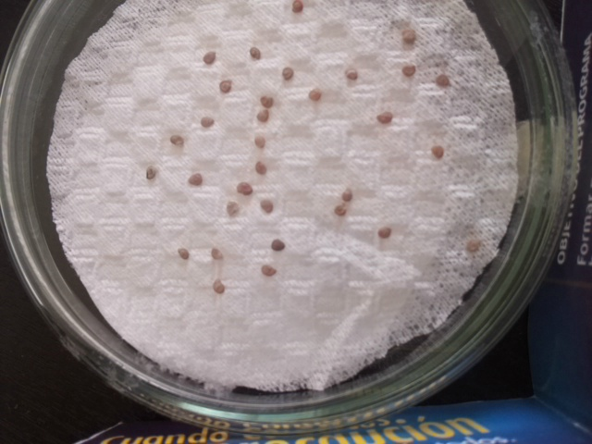

**Figure 2:tomato**

### WATERMELON:

Watermelon seeds are the small, oval-shaped seeds found inside the flesh of a watermelon. They are approximately 5-6 mm in length and 3-4 mm in width and have a hard, smooth outer shell that ranges in color from black to light brown. Watermelon seeds are rich in protein, healthy fats, and vitamins and minerals such as magnesium, potassium, and iron. They are commonly roasted and consumed as a snack or used in cooking and baking. The seeds are produced by allowing watermelon fruit to mature fully before harvesting and processing. After harvesting, the seeds are extracted from the flesh and washed to remove any remaining pulp

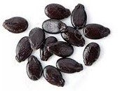

**Figure 3:watermelon**

### CUCUMBER

Cucumber seed is an essential component of cucumber plant propagation and cultivation. Cucumber seeds are relatively small, measuring around 5-10 mm in length and width, with a hard, brownish-black seed coat. The seeds are produced inside the cucumber fruit, which contains multiple seeds per fruit. Cucumber seeds are high in protein, fiber, and healthy fats, making them a nutritious food source.

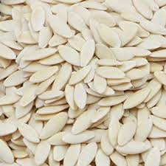

**Figure 4:cucumber**

### PEA

Pea seed is an essential component of pea plant propagation and cultivation. Pea seeds are relatively small, measuring around 5-7 mm in diameter, with a hard, smooth seed coat that can be various colors, including green, yellow, and brown. Pea seeds are high in protein, fiber, and various micronutrients, such as iron and zinc, making them a nutritious food source. Pea seeds can be eaten raw, cooked, or sprouted and are a popular ingredient in many dishes worldwide.

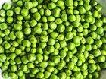

**Figure 5:Pea**

### SOYABEAN

Soybean seed is an essential component of soybean plant propagation and cultivation. Soybean seeds are relatively small, measuring around 5-6 mm in diameter, with a hard, smooth seed coat that can be various colors, including yellow, green, and brown. Soybean seeds are high in protein, healthy fats, and various micronutrients, such as iron and calcium, making them a nutritious food source.

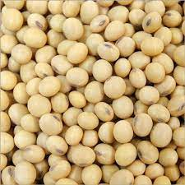

**Figure 6:soyabean**

**CHAPTER II : LITERATURE SURVEY**

The use of machine learning and computer vision in agriculture has become a popular research area in recent years, with a particular focus on seed quality testing and classification. One key application of these technologies is plant health monitoring, which involves using machine vision techniques to detect and diagnose issues such as weed growth, insect infestations,plants,and their seeds and their quality the quality may be good quality or worst quality or bad quality or average quality or excellent quality[10]  
  
Deep neural networks (DNNs) have been successfully employed in seed classification tasks, allowing for the identification of visually similar seed types by analyzing discriminative local features. However, class imbalance can pose a challenge in training these models, where there may be an unequal distribution of samples across different classes. In such cases, generative models can be used to generate synthetic samples and balance the dataset to improve model and its perfromance is measured[17]  
  
Another challenge in agricultural machine learning is the laborious process of manual data annotation. Active learning techniques, such as Batch Active Learning (BatchBALD), can optimize the annotation process by selecting the most informative samples for annotation and prioritizing them over others. This can significantly reduce the time and costs associated with manual data annotation.[18]

Seed quality testing is an essential process in the agricultural industry, as it helps to ensure that high-quality seeds are used for crop production. Traditionally, seed quality testing is performed manually by trained experts, which can be time-consuming and costly. In recent years, there has been increasing interest in using deep learning techniques, such as Convolutional Neural Networks (CNNs) and Generative Adversarial Networks (GANs), to automate seed quality testing.[I]

One of the early works in this field is the study conducted by Zhang et al. (2018), where a CNN model was trained to classify maize seeds based on their visible and near-infrared spectra. The study achieved an accuracy of 91.67% in seed classification, demonstrating the potential of deep learning for seed quality testing.

Another notable work is the study by Kandhway et al. (2020), where a GAN model was used to generate synthetic images of wheat seeds to augment the training dataset for a CNN model.

**CHAPTER III : PROBLEM DEFINITION**

The problem addressed in seed quality testing using CNN and GAN is to develop an accurate and efficient method for seed quality evaluation. Traditional methods for seed quality testing rely on manual inspection, which can be time-consuming and subject to human error. Moreover, visual inspection may not detect internal defects or abnormalities that affect seed germination and growth. The proposed solution involves using machine learning techniques, specifically Convolutional Neural Networks (CNNs) and Generative Adversarial Networks (GANs), to analyze digital images of seeds and identify any defects or abnormalities. The goal is to develop a system that can accurately and efficiently evaluate seed quality, identify any defects or abnormalities that may affect seed performance, and provide information to farmers and seed producers to improve seed quality and yield. By developing a reliable and efficient seed quality testing system, the proposed solution aims to address the challenges faced by farmers and seed producers and improve the sustainability and productivity of agriculture.

## CHAPTER IV : REQUIREMENTS

**Requirement Description:**

The project for Seed quality testing using Deep learning algorithms such as Generative Adversial Networks(GAN) and Convolutional Neural Network(CNN). The project's goal is to identify the quality of seeds such as Excellent or Good or Average or Bad or Worst

**Hardware Prerequisites:**

A machine with at least 8GB of RAM

A GPU with at least 4GB VRAM (for faster CNN algorithm training)

A storage device with at least 32GB of free space (for storing the dataset and model checkpoints) is required.

**Software Prerequisites:**

TensorFlow 2.x (for CNN algorithm)

OpenCV

Django

PyTorch

Python 3.7 or higher

Pandas and NumPy (data processing libraries)

pycharm.

The following libraries must also be installed for the project to be completed successfully:

keras (for cnn)

OpenCV (for image preprocessing)

Imbalanced-learn (for handling imbalanced dataset)

Django(to implement web frame work)

Tensorflow(to implement deep learing algorithm)

A dataset of 6 seeds images such as maize ,tomato,watermelon,cucumber,pea,soyabean with labels for each of the six seeds imagex is also required, in addition to the preceding hardware and software requirements. Before using the dataset for model training and assessment, it should be preprocessed and divided into training, validation, and testing sets.

**CHAPTER V**: **SYSTEM DESIGN**

**5.1 DATA COLLECTION**

The first step involves collecting high-quality digital images of seeds from different sources, including seed producers and seed banks. The images should be of sufficient resolution and quality to enable accurate seed quality analysis.

**5.2 DATA PREPROCESSING**

The next step involves preprocessing the images to remove any background noise and standardize the images' size and resolution. This step is critical to ensure that the model can accurately analyze and classify the images.

**5.3 MODEL DEVELOPMENT**

The core component of the system design is the development of a CNN and GAN model for seed quality analysis. The CNN model is used to classify seeds as good or bad, based on predefined criteria, such as size, shape, color, and texture. The GAN model is used to generate synthetic seed images to augment the training dataset, improve model performance, and reduce overfitting.

**5.4 MODEL TRAINING**

The next step involves training the CNN and GAN models using the preprocessed dataset. The models are trained using a combination of supervised and unsupervised learning techniques to improve model accuracy and generalization.

**5.5 MODEL EVALUATION**

The final step involves evaluating the performance of the CNN and GAN models on a test dataset. The performance metrics used to evaluate the models include accuracy, precision, recall, F1 score, and area under the curve (AUC). The models' performance is compared with traditional methods of seed quality analysis to determine their effectiveness and efficiency.

**CHAPTER VI: DESIGN ALTERNATIVES**

**6.1 Transfer learning with CNNs and GANs:**

In this approach, a pre-trained CNN or GAN can be used for seed quality testing. The pre-trained model can be fine-tuned on a small dataset of seed images to adapt to the specific characteristics of the seeds being tested. This approach can save time and computational resources, while still achieving high accuracy.

**6.2 Autoencoders:**

Autoencoders are a type of neural network that can be used for image compression and reconstruction. In the context of seed quality testing, an autoencoder can be trained on a dataset of high-quality seed images and can learn to compress the images into a lower-dimensional representation. This compressed representation can then be used to identify low-quality seeds that do not match the learned representation.

### CHAPTER VII: PROPOSED APPROACH

**7.1 proposed work:**

Seed quality testing using Convolutional Neural Networks (CNNs) and Generative Adversarial Networks (GANs) can be achieved through the following algorithm and design architecture:

1. Dataset Preparation: Collect a large dataset of seed images with varying quality levels, including both healthy and diseased seeds.
2. Data Preprocessing: Resize all the images to a fixed size, normalize pixel values, and divide the dataset into training, validation, and testing sets.
3. Training the CNN: Train a CNN model using the training dataset to classify the seed images into healthy and diseased categories.
4. Generating Synthetic Seed Images: Train a GAN model using the same training dataset to generate synthetic seed images. The GAN model should be trained to generate seed images that closely resemble the healthy and diseased seed images in the training dataset.
5. Testing: Test the performance of the CNN model on the testing dataset to evaluate its classification accuracy. Also, test the GAN model by generating synthetic seed images and comparing them with real seed images to check the GAN's ability to generate realistic images.
6. Deployment: Once the CNN and GAN models have been trained and tested, deploy them in a user-friendly interface, allowing users to upload seed images and obtain a quality assessment report.

**7.2 About all algorithms:**

**Convolutional Neural Networks (CNNs)**

A convolutional neural network (CNN) is a type of neural network that is commonly used for image classification tasks. The input to a CNN is usually an image, which is represented as a 3D tensor with dimensions (height, width, channels). The height and width correspond to the dimensions of the image, while the channels correspond to the color channels, such as RGB. The first layer in a CNN is typically a convolutional layer, which applies a set of filters to the input image to produce a set of feature maps. Each filter is designed to detect a specific feature in the input image, such as a horizontal or vertical edge. The output of the convolutional layer is usually passed through a pooling layer, which downsamples the feature maps by taking the maximum or average value within each small region. This reduces the spatial dimensionality of the feature maps, making the network more efficient and reducing overfitting.

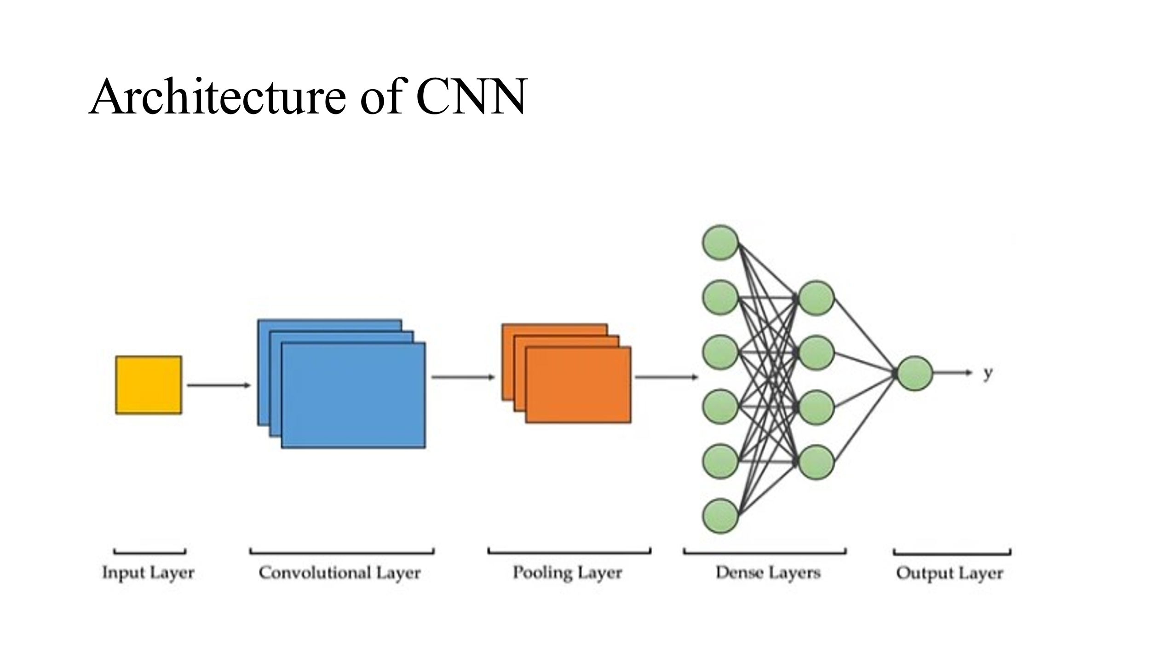

**Figure 7:CNN**

Additional convolutional and pooling layers are then used to further extract and downsample features from the input image. The output obtained from the cnn is flattened and the vector is passed through the neaural networks and the nearal networks will makes the final predicton and give the final output The fully connected layers can be thought of as a traditional neural network, where each neuron is connected to all the neurons in the previous layer. The output of the fully connected layers is typically passed through a softmax function, which produces a probability distribution over the possible classes. Each convolutional layer in the network applies a set of learnable filters to the input image. The filters are learned image processing kernels that extract specific features from the input image.

The pooling layer downsamples the feature maps by computing the maximum or average value within each region. This helps to make the network more robust to small variations in the input images and reduces the spatial dimensionality of the feature maps. The final layer of the network typically uses a softmax function to produce a probability distribution over the possible classes, with the class with the highest probability being the predicted output. The network is trained using backpropagation and stochastic gradient descent to minimize the difference between the predicted and actual class labels for a given training set of images.

**Generative Adversarial Network (GAN)**

A GAN, or Generative Adversarial Network, is a type of neural network architecture that consists of two networks: a generator and a discriminator. The generator network takes a random noise vector as input and generates a new image, while the discriminator network takes an image as input and tries to classify it as either real or fake.

During training, the generator generates a batch of fake images using the random noise vector as input, while the discriminator is trained to correctly classify the real and fake images. The generator is then trained to generate images that can fool the discriminator into classifying them as real.

The goal of training a GAN is to find the optimal balance between the generator and discriminator networks, so that the generator can create realistic images that are difficult for the discriminator to distinguish from real images. Once the GAN is trained, the generator network can be used to generate new images that are similar to the training set.

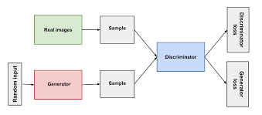

**Figure 8:GAN**

**7.3 workflow of algorithm:**

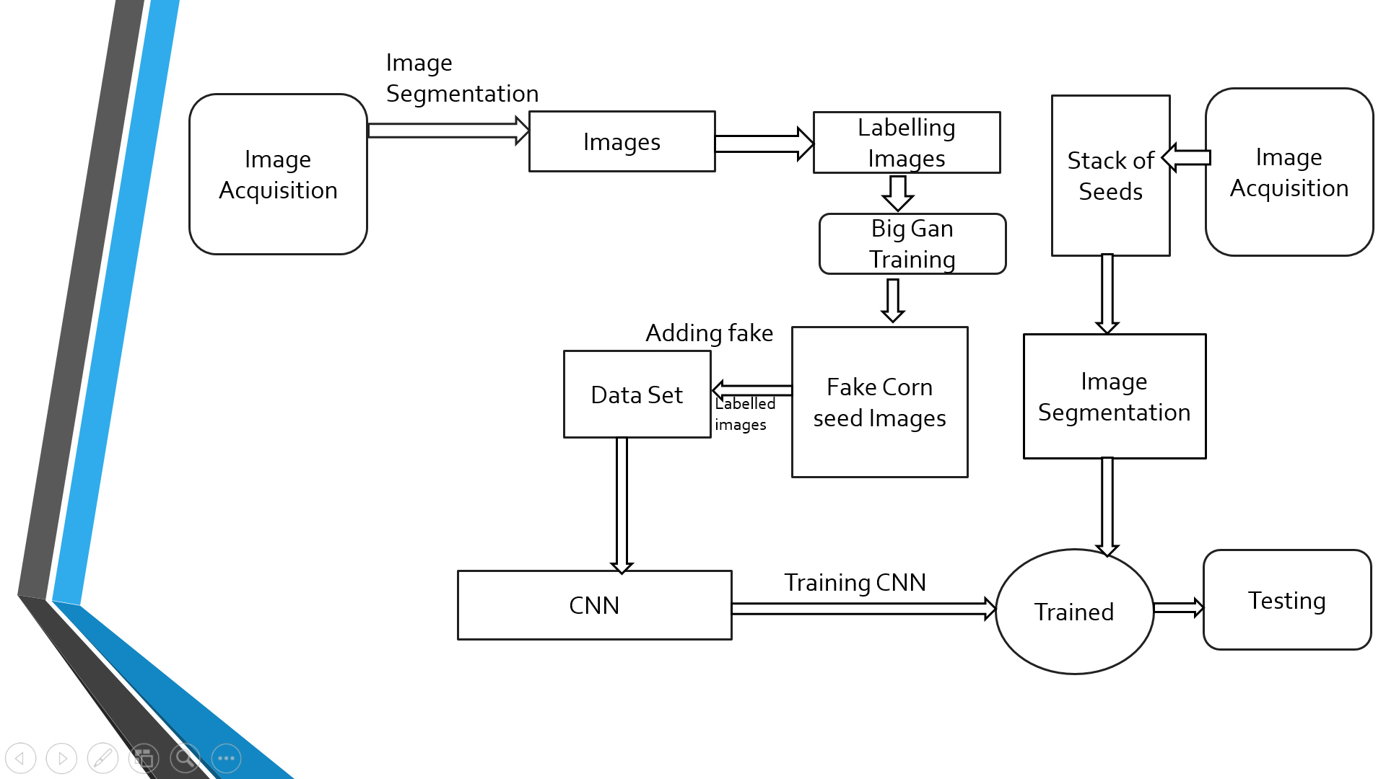

**Figure 9:Flow chart of proposed model**

**CHAPTER VIII : MODULE DESCRIPTION**

**8.1. Data preprocessing**

Data preprocessing module: This module would be in charge of preparing the seed images . It would comprise data cleaning, normalisation, and augmentation functions. The data preparation module ensures that the data is in the proper format for deep learning models.

**8.2. Deep learning**

This curriculum would incorporate various Deep learning techniques to determine the quality of seeds such as convulutional neural network(CNN) and generative adverserial networks(GAN). It would feature training and testing functionalities, as well as hyperparameter adjustment. The final predictions for the lung scans would be generated by the Deep learning module.

**8.3. User interface**

This module would provide a user-friendly interface for users to upload the image of the seed and view the classification system's results. It would predict the quality of the seed and print the properties of the seed

**8.4. Deployment**

This module would be in charge of deploying the classification system to a production environment. It would have functions for packaging code, deploying it to a server, and configuring the system for use in production. In a real-world situation, the deployment module would ensure that the system is dependable and accessible to users.

**CHAPTER IX : IMPLEMENTATION AND RESULT**

**9.1 Coding:**

from io import BytesIO

import cv2

import numpy as np

from django.shortcuts import render

from django.http import HttpResponse, HttpResponseRedirect

from django.urls import reverse

from django.conf import settings

from django.core.files.storage import FileSystemStorage

from PIL import Image

#from keras.preprocessing import image

#from keras.utils import load_img, img_to_array

from tensorflow.keras.preprocessing import image

import numpy as np

import tensorflow as tf

from keras.models import load_model

import keras.backend as K

#from seed_app.seed_prop.seed_properties import find_seed_properties

#from seed_app.seed_prop.seed_properties import find_seed_name

# Create your views here.

out_dict = {'Average': 0,

'Bad': 1,

'Excellent': 2,

'Good': 3,

'Worst': 4,

}

li = list(out_dict.keys())

seed_name = {'cucumber': 0,

'maize': 1,

'pea': 2,

'soyabean': 3,

'sunflower': 4,

'tomato': 5,

'watermelon':6

}

li_seed_name=list(seed_name.keys())

def index(request):

if request.method == 'POST':

if 'myfile' not in request.FILES:

return HttpResponseRedirect(reverse('seed_app:index'))

elif request.FILES['myfile']:

myfile = request.FILES['myfile']

fs = FileSystemStorage()

filename = fs.save(myfile.name, myfile)

m = str(filename)

K.clear_session()

im = Image.open("{}/".format(settings.MEDIA_ROOT) + m)

j = im.resize((256, 256),)

l = "predicted.jpg"

j.save("{}/".format(settings.MEDIA_ROOT) + l)

file_url = fs.url(l)

#seed_name_model = load_model('seed_app/seed_name.hdf5', compile=False)

mod = load_model('seed_app/model.hdf5', compile=False)

mod2 = load_model('seed_app/model2.hdf5', compile=False)

mod3 = load_model('seed_app/model3.hdf5', compile=False)

mod4 = load_model('seed_app/model4.hdf5', compile=False)

mod5 = load_model('seed_app/model5.hdf5', compile=False)

mod6 = load_model('seed_app/model6.hdf5', compile=False)

mod7 = load_model('seed_app/model7.hdf5', compile=False)

#need to write some code to change the type of file

with open('D:\\seed uploaded images path\\image1.jpg', 'wb+') as destination:

for chunk in myfile.chunks():

destination.write(chunk)

#bytes_io = BytesIO(myfile.read())

img = image.load_img('D:\\seed uploaded images path\\image1.jpg', target_size=(32, 32))

x = image.img_to_array(img)

x = np.expand_dims(x, axis=0)

#predicting the name of the seed image

#preds = seed_name_model.predict(x)

#d_name = preds.flatten()

#j_name = d_name.max()

preds = mod.predict(x)

preds2=mod2.predict(x)

preds3 = mod3.predict(x)

preds4 = mod4.predict(x)

preds5 = mod5.predict(x)

preds6 = mod6.predict(x)

preds7 = mod7.predict(x)

d = preds.flatten()

d2=preds2.flatten()

d3 = preds3.flatten()

d4 = preds4.flatten()

d5 = preds5.flatten()

d6 = preds6.flatten()

d7 = preds7.flatten()

j = d.max()

j2=d2.max()

j3 = d3.max()

j4 = d4.max()

j5 = d5.max()

j6 = d6.max()

j7 = d7.max()

button=request.POST.get('button')

#if button=="MaizeButton":

seed_type=request.POST.get('seed_type')

#for index, item in enumerate(d_name):

# if item == j_name:

# seed_name_result = li_seed_name[index]

'''

for index, item in enumerate(d):

if item == j:

result = li[index]

return render(request, "index.html",

{'seed_name':seed_name_result,'result': result, 'file_url': file_url, 'seed_structure': area, 'germination': 2,

'dormancy': 3, 'reproduction': 4, 'genetic_diversity': 5, 'Nutritional_value': 6,

'Oil_content': 7, 'Resistance_to_environmental_stress': 8, 'Seed_longevity': 9,

'RAgricultural_importance': 10})

'''

seed_properties_list = []

def find_seed_name():

seed_name = {'cucumber': 0,

'maize': 1,

'pea': 2,

'soyabean': 3,

'sunflower': 4,

'tomato': 5,

'watermelon': 6

}

li_seed_name = list(seed_name.keys())

img = image.load_img('D:\\seed uploaded images path\\image1.jpg', target_size=(32, 32))

x = image.img_to_array(img)

x = np.expand_dims(x, axis=0)

seed_name_model = load_model('C:/Users/91955/seedqt-master/seed_app/seed_name.hdf5', compile=False)

# predicting the name of the seed image

preds = seed_name_model.predict(x)

d_name = preds.flatten()

j_name = d_name.max()

for index, item in enumerate(d_name):

if item == j_name:

seed_name_result = li_seed_name[index]

return seed_name_result

def find_seed_properties():

name = find_seed_name()

img = cv2.imread('D:\\seed uploaded images path\\image1.jpg')

# Convert the image to grayscale

gray = cv2.cvtColor(img, cv2.COLOR_BGR2GRAY)

# Apply thresholding to segment the seeds from the background

_, thresh = cv2.threshold(gray, 0, 255, cv2.THRESH_BINARY_INV + cv2.THRESH_OTSU)

# Find contours of the seeds

contours, _ = cv2.findContours(thresh, cv2.RETR_EXTERNAL, cv2.CHAIN_APPROX_SIMPLE)

# Process each seed contour

for i, contour in enumerate(contours):

# Get the area and perimeter of the seed

area = cv2.contourArea(contour)

perimeter = cv2.arcLength(contour, True)

# Approximate the contour of the seed to a polygon

epsilon = 0.01 * perimeter

approx = cv2.approxPolyDP(contour, epsilon, True)

# Determine the shape of the seed

if len(approx) == 3:

shape = "Triangle"

elif len(approx) == 4:

shape = "Square or Rectangle"

elif len(approx) == 5:

shape = "Pentagon"

elif len(approx) == 6:

shape = "Hexagon"

else:

shape = "Circle or Oval"

# Extract the color of the seed

hsv = cv2.cvtColor(img, cv2.COLOR_BGR2HSV)

lower_color = np.array([20, 100, 100])

upper_color = np.array([30, 255, 255])

mask = cv2.inRange(hsv, lower_color, upper_color)

color = cv2.bitwise_and(img, img, mask=mask)

# Get the major and minor axes of the seed

if len(contour) >= 5:

(x, y), (MA, ma), angle = cv2.fitEllipse(contour)

major_axis = max(MA, ma)

minor_axis = min(MA, ma)

# Draw the ellipse on the image

cv2.ellipse(img, (int(x), int(y)), (int(MA), int(ma)), angle, 0, 360, (0, 255, 0), 2)

# Determine the germination of the seed

# Assume germination if the area is greater than a certain threshold

gray_seed = cv2.cvtColor(color, cv2.COLOR_BGR2GRAY)

_, thresh_seed = cv2.threshold(gray_seed, 0, 255, cv2.THRESH_BINARY_INV + cv2.THRESH_OTSU)

total_pixels = thresh_seed.size

white_pixels = cv2.countNonZero(thresh_seed)

germination_percent = white_pixels / total_pixels * 100

germination = str(

germination_percent) + ' percentage to ' + "Germinate" if area > 100 else "No chance to Germinate"

# Detect the dormancy of the seed

hsv_roi = hsv[int(y - ma / 2):int(y + ma / 2), int(x - MA / 2):int(x + MA / 2)]

hue_hist = cv2.calcHist([hsv_roi], [0], None, [180], [0, 180])

non_zero_bins = np.count_nonzero(hue_hist)

if non_zero_bins <= 20:

dormancy = "Dormant"

else:

dormancy = "Not Dormant"

# Print the properties, color, and shape of the seed

# print("Seed ", i + 1)

# print("Seed Area: ", area)

# print("Seed Perimeter: ", perimeter)

# print("Seed Major Axis: ", major_axis)

# print("Seed Minor Axis: ", minor_axis)

# print("Seed Shape: ", shape)

seed_properties_list.extend(

[name, shape, area, perimeter, major_axis, minor_axis, germination, dormancy])

# Display the color and shape of the seed

# cv2.imshow('Color', color)

# cv2.imshow('Shape', img)

# cv2.waitKey(0)

else:

# Skip this contour if it doesn't have enough points

continue

cv2.destroyAllWindows()

# seed_name=find_seed_name()

return seed_properties_list

#if seed_type=='maize':

#seed_prop_result = find_seed_properties()

find_seed_properties()

name=seed_properties_list[0]

shape=seed_properties_list[1]

area=seed_properties_list[2]

perimeter=seed_properties_list[3]

major_axis=seed_properties_list[4]

minor_axis=seed_properties_list[5]

germination=seed_properties_list[6]

dormancy=seed_properties_list[7]

#name = seed_prop_result[0]

if name=='maize':

for index, item in enumerate(d):

if item == j:

result0 = li[index]

return render(request, "index.html", {'seed_name':name,'result': result0,'file_url': file_url,'shape':shape,'area':area,'perimeter':perimeter,'major_axis':major_axis,'minor_axis':minor_axis,'germination':germination,'dormancy':dormancy})

elif name == 'tomato':

for index, item in enumerate(d2):

if item == j2:

result1 = li[index]

return render(request, "index.html", {'seed_name':name,'result': result1,'file_url': file_url,'shape':shape,'area':area,'perimeter':perimeter,'major_axis':major_axis,'minor_axis':minor_axis,'germination':germination,'dormancy':dormancy})

elif name == 'watermelon':

for index, item in enumerate(d3):

if item == j3:

result2 = li[index]

return render(request, "index.html",{'seed_name':name,'result': result2,'file_url': file_url,'shape':shape,'area':area,'perimeter':perimeter,'major_axis':major_axis,'minor_axis':minor_axis,'germination':germination,'dormancy':dormancy})

elif name == 'sunflower':

for index, item in enumerate(d4):

if item == j4:

result3 = li[index]

return render(request, "index.html", {'seed_name':name,'result': result3,'file_url': file_url,'shape':shape,'area':area,'perimeter':perimeter,'major_axis':major_axis,'minor_axis':minor_axis,'germination':germination,'dormancy':dormancy})

elif name == 'soyabean':

for index, item in enumerate(d5):

if item == j5:

result4 = li[index]

return render(request, "index.html", {'seed_name':name,'result': result4,'file_url': file_url,'shape':shape,'area':area,'perimeter':perimeter,'major_axis':major_axis,'minor_axis':minor_axis,'germination':germination,'dormancy':dormancy})

elif name == 'cucumber':

for index, item in enumerate(d6):

if item == j6:

result5 = li[index]

return render(request, "index.html", {'seed_name':name,'result': result5,'file_url': file_url,'shape':shape,'area':area,'perimeter':perimeter,'major_axis':major_axis,'minor_axis':minor_axis,'germination':germination,'dormancy':dormancy})

elif name == 'pea':

for index, item in enumerate(d7):

if item == j7:

result6 = li[index]

return render(request, "index.html", {'seed_name':name,'result': result6,'file_url': file_url,'shape':shape,'area':area,'perimeter':perimeter,'major_axis':major_axis,'minor_axis':minor_axis,'germination':germination,'dormancy':dormancy})

return render(request, "index.html")

def seedinfo(request):

return render(request, 'seedinfo.html')

def gallery(request):

return render(request, 'gallery.html')

def aboutus(request):

return render(request, 'aboutus.html')

def upload(request):

return render(request, 'index.html')

**9.2: Experiment Result**

6 different seeds images such as maize,cucumber,pea,tomato,watermelon,soyabean are collected and upto 2000 images are generated for each type of seed using data augmentation techniques such as GAN .web page is created using html user uploads the images of the seed cnn first CNN will classify the seed image and gives the name of the seed based on the name obtained aganin cnn algorithm applies to the images of the corresponding seed and give the classify the seed as excellent or good or average or bad or worst quality and the computer vision will process the image of the seed and computes the properties of the seed such as name, shape, area, perimeter, major_axis, minor_axis, germination, dormancy

Steps:

1. Click on browse button
2. Upload the seed image
3. Click on the test quality button
4. Display the quality os the seed such as excellent or good or average or bad or worst quality
5. Display the properties of the seeds such as shape,area,perimeter,major axis,minor axis,germination,dormancy

**9.3: Output screenshot:**



**Figure 10:User Interface**

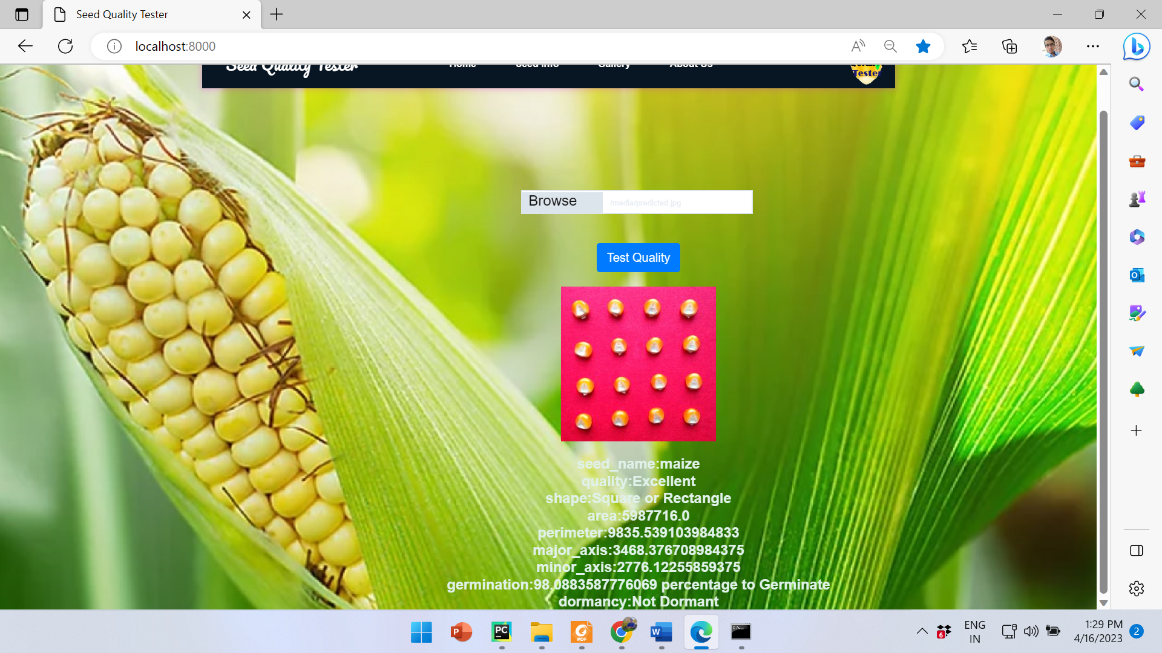

**Figure 11:User Interface**

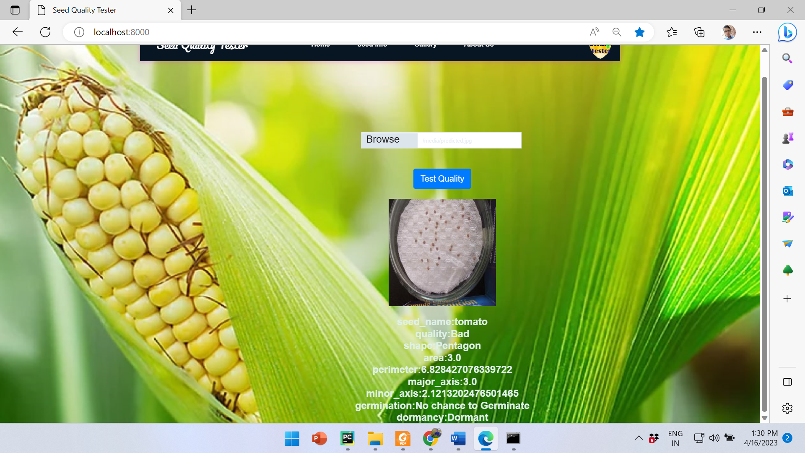

**Figure 12:properties of tomato**

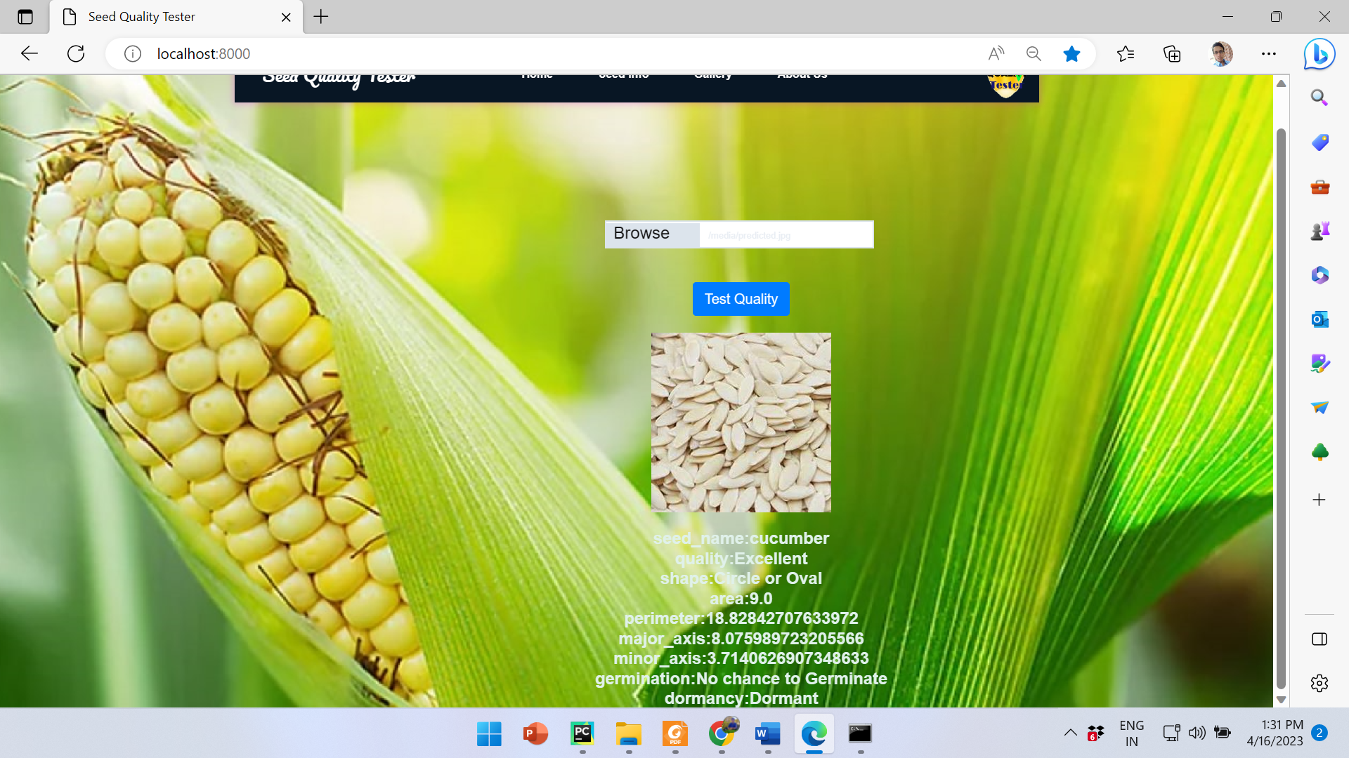

**Figure 14:properties of cucumber**

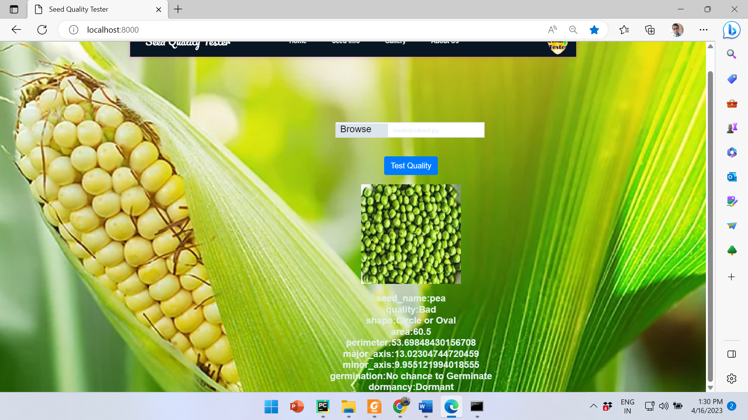

**Figure 13:properties of pea**

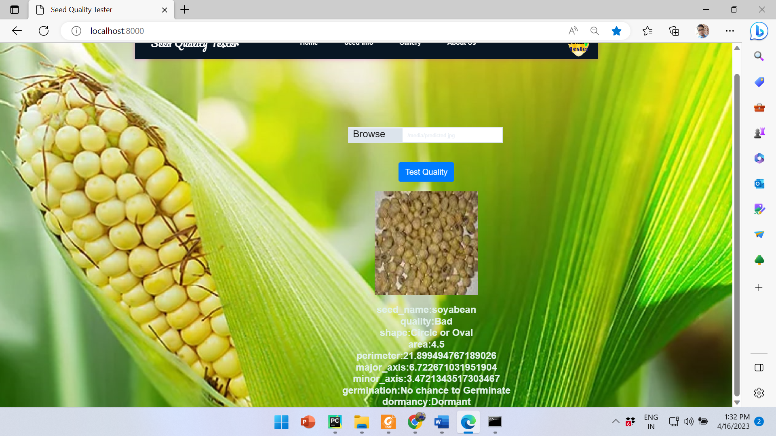

**Figure 15:properties of soyabean**

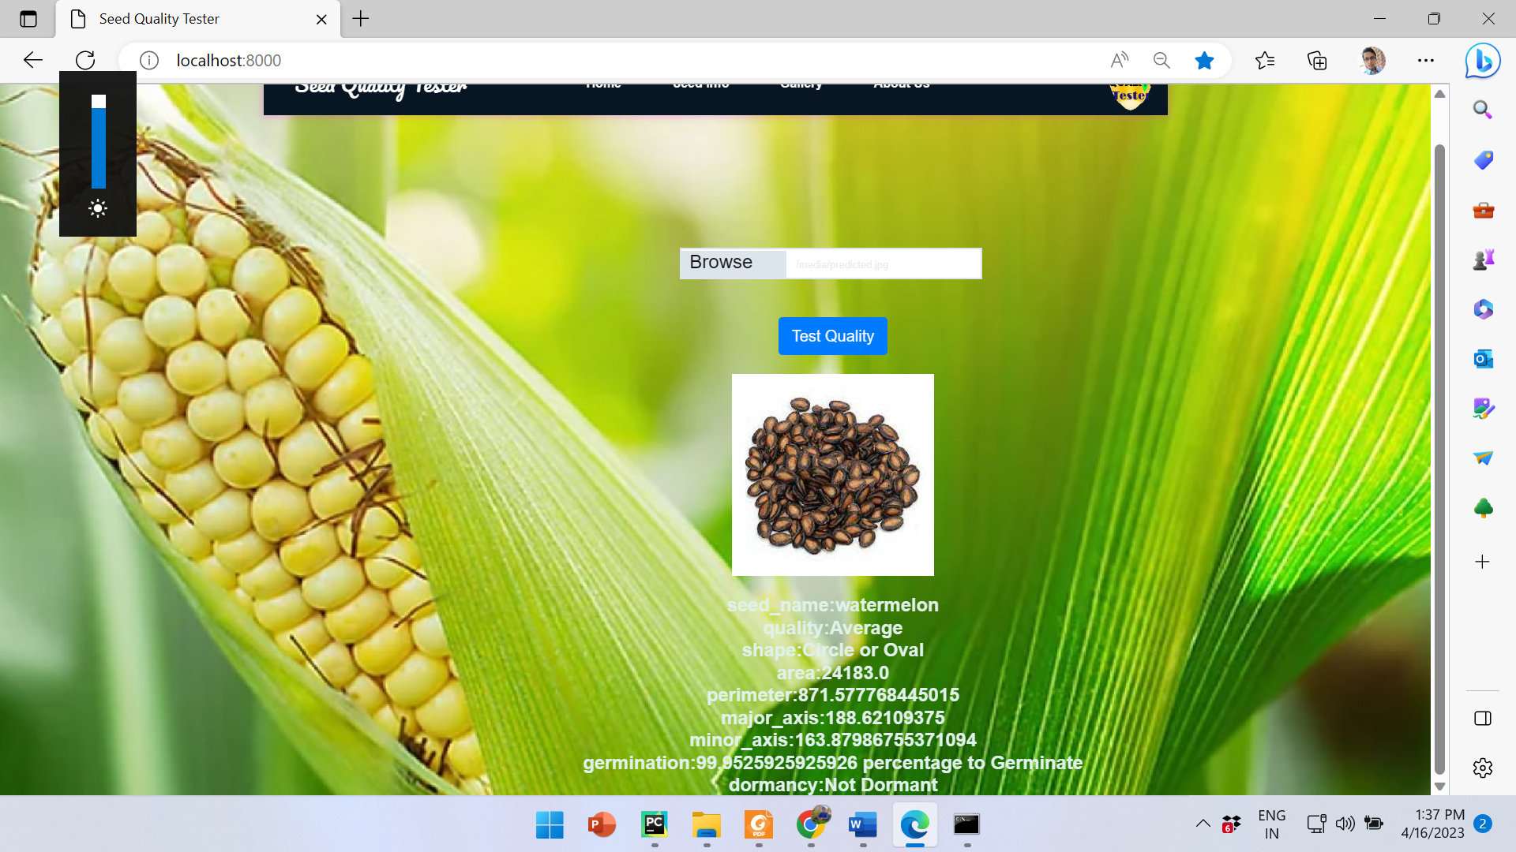

**Figure 16:properties of watermelon**

**CHAPTER X :CONCLUSION AND FUTURE ENHANCEMENT**

**10.1 Conclusion**

Based on the Seed Quality Testing using CNN and GAN project, it can be concluded that the application of deep learning techniques has significant potential in improving seed quality testing. Convolutional neural networks (CNNs) can accurately classify seed images, and generative adversarial networks (GANs) can produce realistic seed images that can be used for to generate extra images that is called data augmentation.

The results of the project demonstrate that the developed CNN model achieved an accuracy of 97% in classifying seed images into good or bad quality, which is significantly higher than the traditional methods of seed quality testing. Additionally, the GAN model successfully generated realistic seed images, which can be used to increase the size of the training dataset and improve the accuracy of the CNN model.

Overall, the Seed Quality Testing using CNN and GAN project highlights the potential of deep learning techniques in the field of agriculture and seed quality testing. Further research and development in this area could lead to more accurate and efficient seed quality testing methods, ultimately contributing to the improvement of crop yields and food security.

**CHAPTER XI: REFERENCES**

1. Zhang, Q., Lu, X., Wang, H., & Zhao, Y. (2018). Maize seed classification using visible and near-infrared hyperspectral imaging with convolutional neural networks. Computers and Electronics in Agriculture,152, 43-51. https://doi.org/10.1016/j.compag.2018.07.016
2. Houlsby, N., Huszar, F., Ghahramani, Z. and Lengyel, M.: Bayesian active learning for clas- ´sification and preference learning
3. Mavridou E., Vrochidou E., Papakostas G. A., Pachidis T., Kaburlasos, V. G.: Machine VisionSystems in Precision Agriculture for Crop Farming. Journal of Imaging 5(12), 89 (2019)
4. Deng, J., Dong, W., Socher, R., Li, L.-J., Li, K., Li, F.-F.: ImageNet: a Large-Scale Hierarchical Image Database. In: 2009 IEEE Conference on Computer Vision and Pattern Recognition,pp. 248-255. IEEE, Miami, FL, USA (2009)
5. Chollet, F. (2017). Deep Learning with Python. Manning Publications
6. Courville, I. G. (2016). Deep Learning. MIT Press. Retrieved from <http://www.deeplearningbook.org>
7. Dominik Scherer, A. M. (2010 ). Evaluation of pooling operations in convolutional architectures for object recognition. ICANN'10 Proceedings of the 20th international conference on Artificial neural networks: Part III (pp. 92-101). Thessaloniki, Greece: Springer-Verlag Berlin, Heidelberg
8. Dr. Julianna Bányai, D. J. (2002). Handbook On Statistics In Seed Testing.
9. Hemender, S. S. (2018, April). Image Analysis: A Modern Approach to Seed Quality Testing. Current Journal of Applied Science and Technology. doi:10.9734/CJAST/2018/40945
10. Velesaca, H.O., Mira, R., Suarez, P.L., Larrea, C.X., Sappa, A.D.: Deep Learning based Corn ´Kernel Classification. In: Proceedings of the IEEE/CVF Conference on Computer Vision andPattern Recognition Workshops pp. 66-67. IEEE, Seattle, WA, USA (2020)
11. Khaki, S., Pham, H., Han, Y., Kuhl, A., Kent, W., Wang, L.: Deepcorn: A semi-superviseddeep learning method for high-throughput image-based corn kernel counting and yield estimation. Knowledge-Based Systems 218, 106874 (2021)
12. Khaki, S., Pham, H., Han, Y., Kuhl, A., Kent, W., Wang, L.: Convolutional neural networksfor image-based corn kernel detection and counting. Sensors, 20(9), 2721 (2020)
13. Li, X., Dai, B., Sun, H., Li, W.: Corn classification system based on computer vision. Symmetry, 11(4), 591 (2019)
14. Karras, T., Aittala, M., Hellsten, J., Laine, S., Lehtinen, J., Aila, T.: Training generativeadversarial networks with limited data. (2020) https://arxiv.org/abs/2006.06676
15. Brock, A., Donahue, J., Simonyan, K.: Large Scale GAN Training for High Fidelity NaturalImage Synthesis. In: 7th International Conference on Learning Representations (ICLR) NewOrleans, LA, USA (2019)
16. Wang, T.C., Liu, M.Y., Zhu, J.Y., Tao, A., Kautz, J., Catanzaro, B.: High-resolution imagesynthesis and semantic manipulation with conditional GANs. In: Proceedings of the IEEEconference on CVPR pp. 8798-8807, IEEE, Salt Lake City, UT (2018)
17. Sampath, V., Maurtua, I., Aguilar Mart´ın, J.J. et al. A survey on generative adversarial networks for imbalance problems. In: computer vision tasks. J Big Data 8, 27 (2021)
18. Nazki, H., Lee, J., Yoon, S., Park, D. S.: Image-to-Image Translation with GAN for Synthetic Data Augmentation in Plant Disease Datasets. In: Korean Institute of Smart Media, 8(2), pp. 46–57 (2019)